Lesson by Julie 4.17.24
To Be or Not to Be
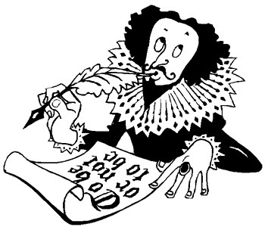

We use the Be verb in the simple present tense to show a state of being.
• She is a nurse.
• The dogs are hungry.

What are "to be" verbs?

am, is, are, was, were, will be, been!

The only "to be" verbs are those in the chart below:

TO BE VERBS
Person | Present | Past | Past Participle (used with "have") | Future
I | am | was | have been | will be
you | are | were | have been | will be
he/she/it | is | was | has been | will be
we | are | were | have been | will be
you (plural) | are | were | have been | will be
they | are | were | have been | will be

Positive Sentences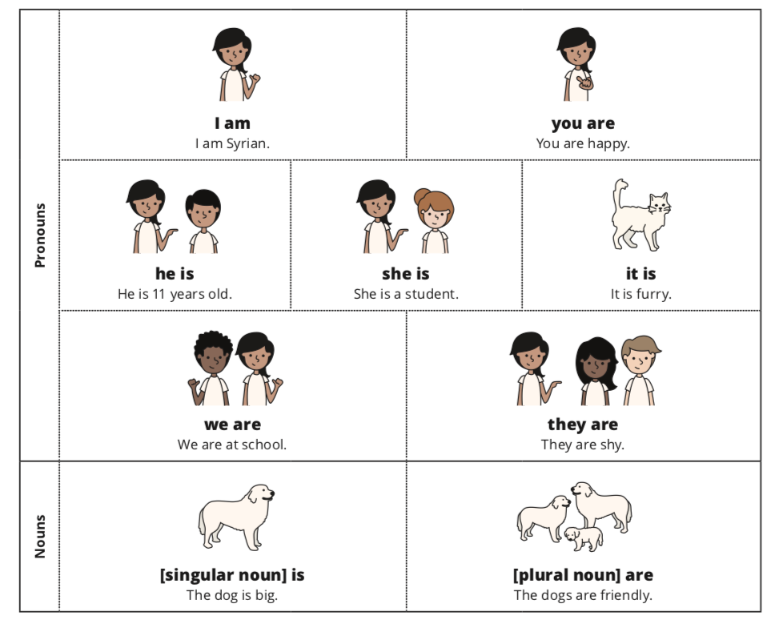

Negative Sentences
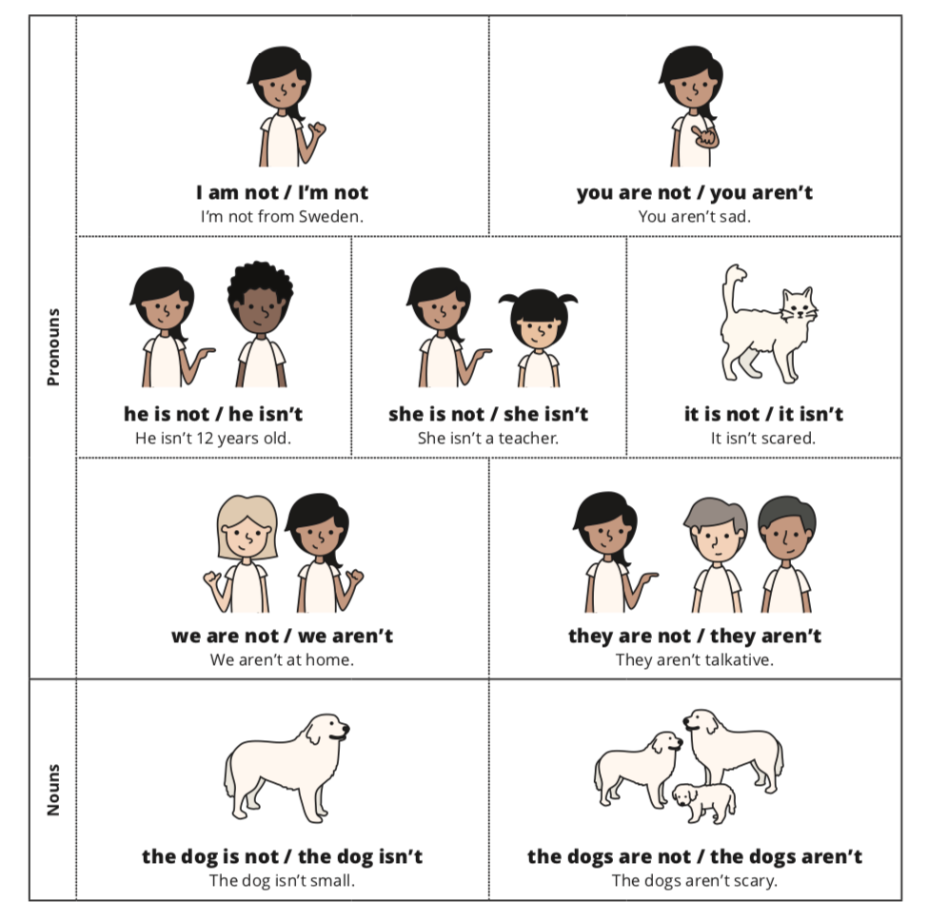

Yes/No Questions and Short Answers
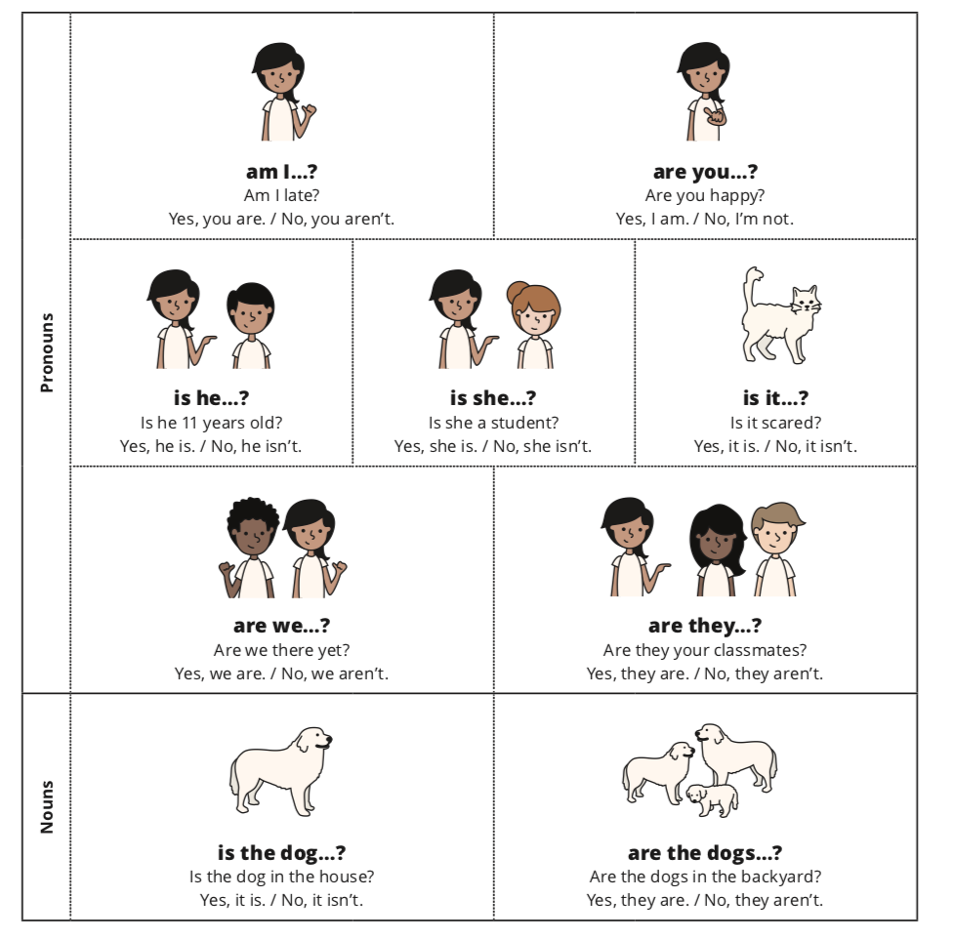

Wh- Questions (what, where, when, who, why, how)
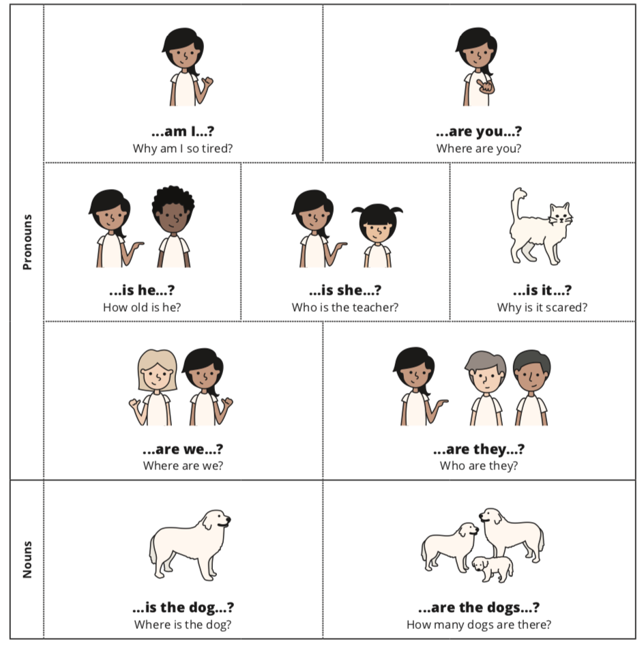

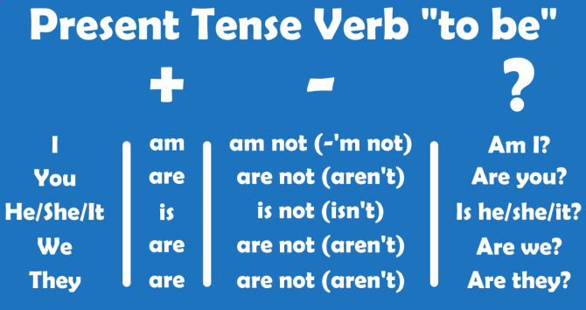

+ Positive Sentences
Write a pronoun and the correct form of the Be verb under each picture.

ex . she is

Fill in the Blank
Complete the sentences using the Be verb.
Ex. She is 16 years old.

1. New York a big city.

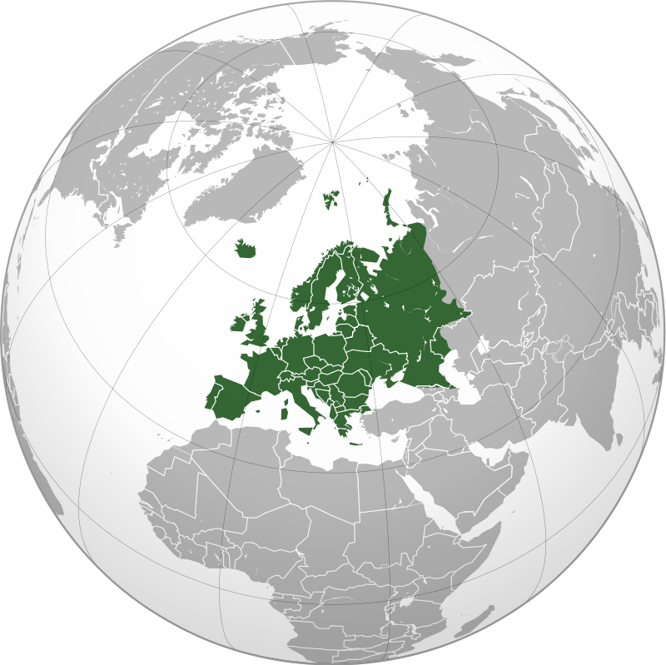
2. She friendly.

3. He five years old.

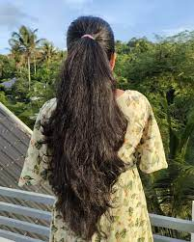
4. Sweden and France countries in Europe.

5. Her hair long.

6. It very cold today.

7. The cat furry.
8. The dog hungry.

9. They friendly.

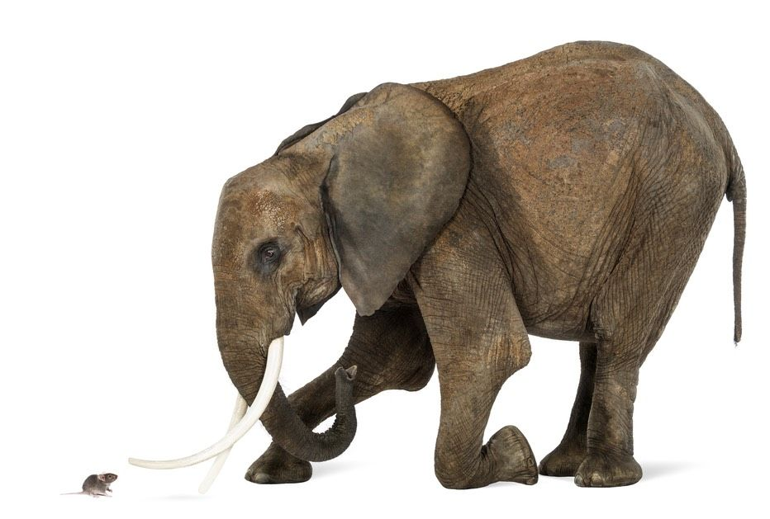
10. An elephant a big animal.

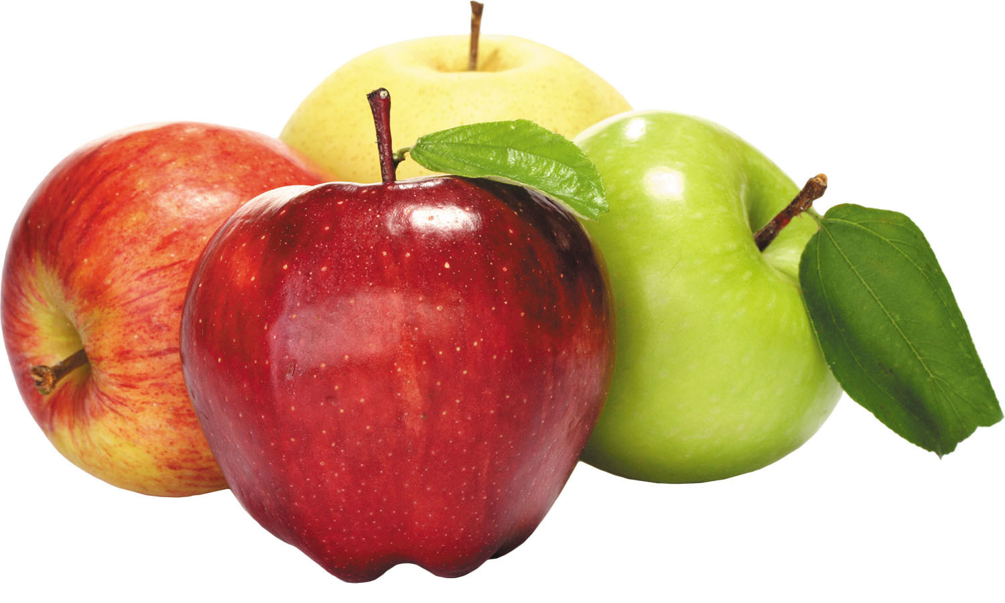
11. Mice small.

12. Apples red.

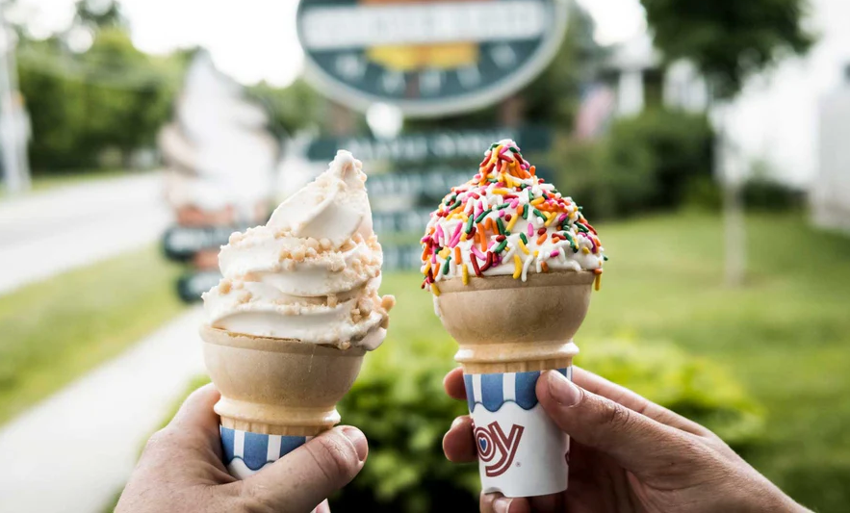
13. You smart.

14. Ice cream sweet.

15. The bus late.
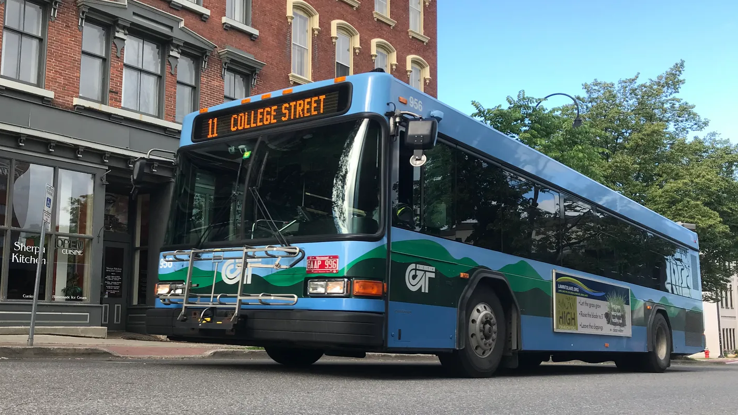
16. He 25 years old.

17. I tired.

18. Mr. and Mrs. Baker teachers.
19. We sleepy today.

Complete the Sentence
Complete the following sentences using the Be verb and a noun from the box. Use a or an with a singular noun or use the correct plural form.

Ex. The Mona Lisa is a painting .  1. A cat .  2. Roses .  3. A Toyota .  4. New York and Paris .  5. Sweden .  6. A dictionary .  7. Spring and fall .  8. A teacher .  9. A doll .  10. Ants and flies .  11. A crow .  12. Shirts and pants .  13. Toy Story .  14. A piano and a guitar .  15. Carrots and cucumbers . | Noun List:  • flower  • toy  • painting  • season  • clothes  • bird  • animal  • car  • city  • person  • insect  • country  • book  • movie  • vegetable  • instrument

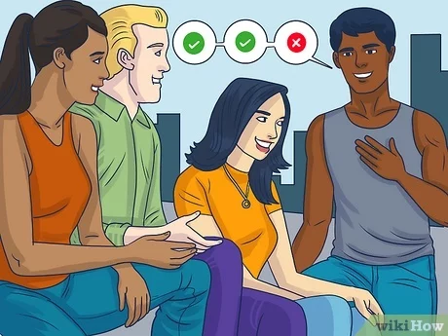
Two Truths and a Lie
Go around the group and everyone has to say two true statements about themselves and one false.
The rest of the group has to guess which one is false. You may be surprised. You can learn some crazy things about each other!

Ex.

I have been an English teacher for three years
I am a mom
I was an art major in college

Where Were You
Take little slips of paper; write a different year on each of them; put in a jar. Partners pull one out and tell what they were doing/”where they were” that year.

Year: 2010
Partner 1: “What were you doing in 2010?”
Partner 2: “I was in my Freshman year of highschool!”

From another jar, pull the names of classmates. Repeat back where they had said they were and in what year.

Name: Person 3
“In 2010 Partner 2 was in India with her family”

+ Positive and - Negative Sentences
Write the correct positive and negative forms of the Be verb.
Ex. Carrots are vegetables. They aren’t fruit.

1. Tokyo a city. It a country.

2. A feather heavy. It light.
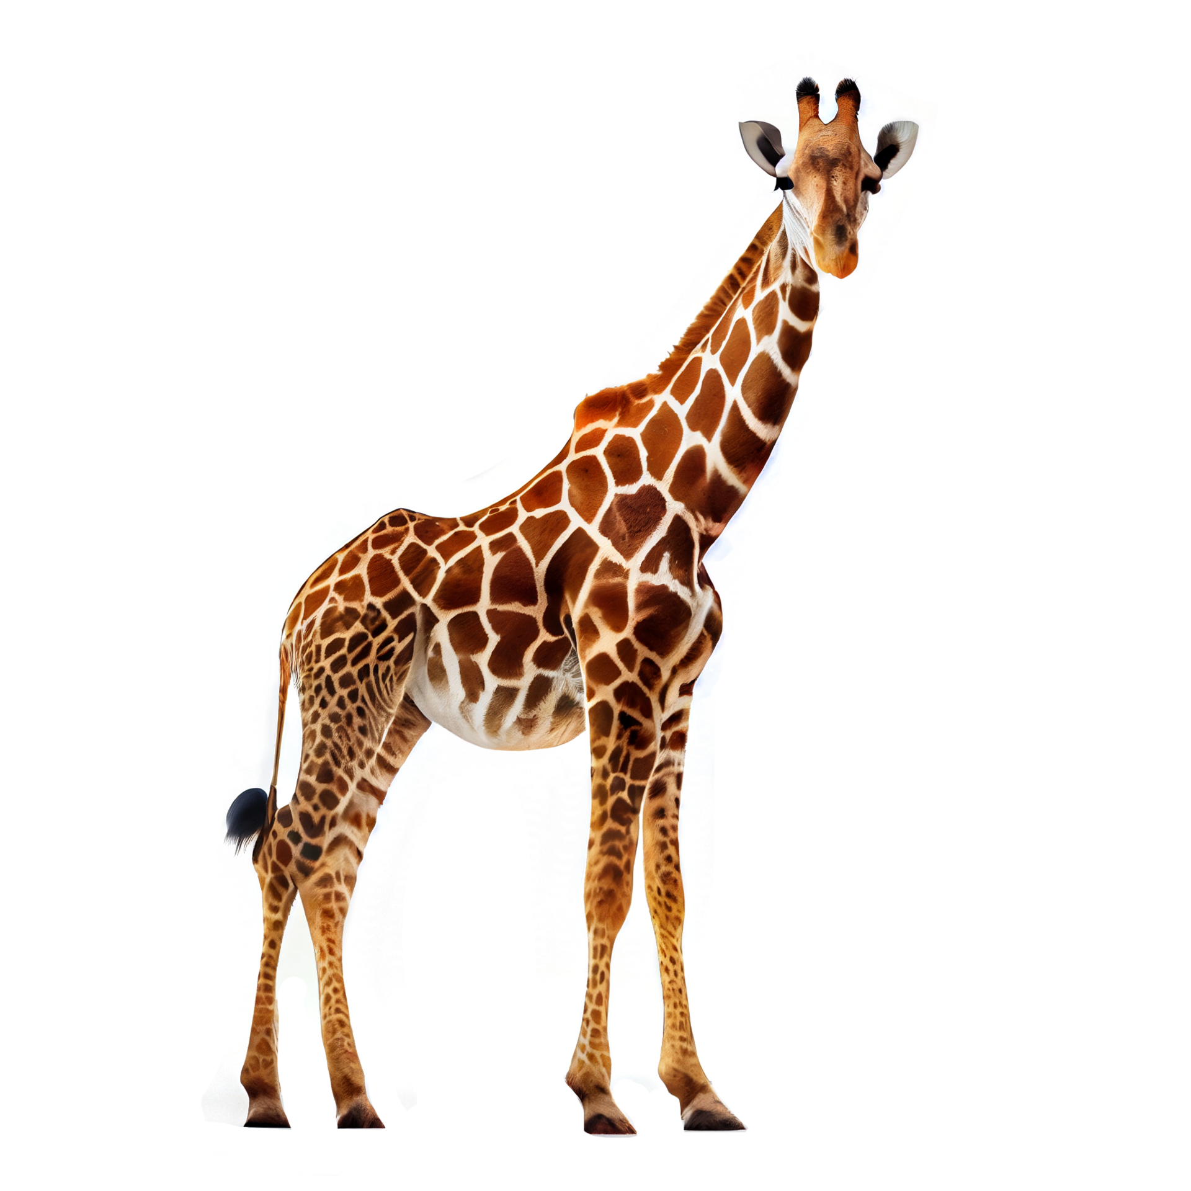
3. Winters cold in Canada. They hot.

4. Ice cream sweet. It sour.

5. Giraffes tall animals. They short.

6. Hockey a fast game. It slow.
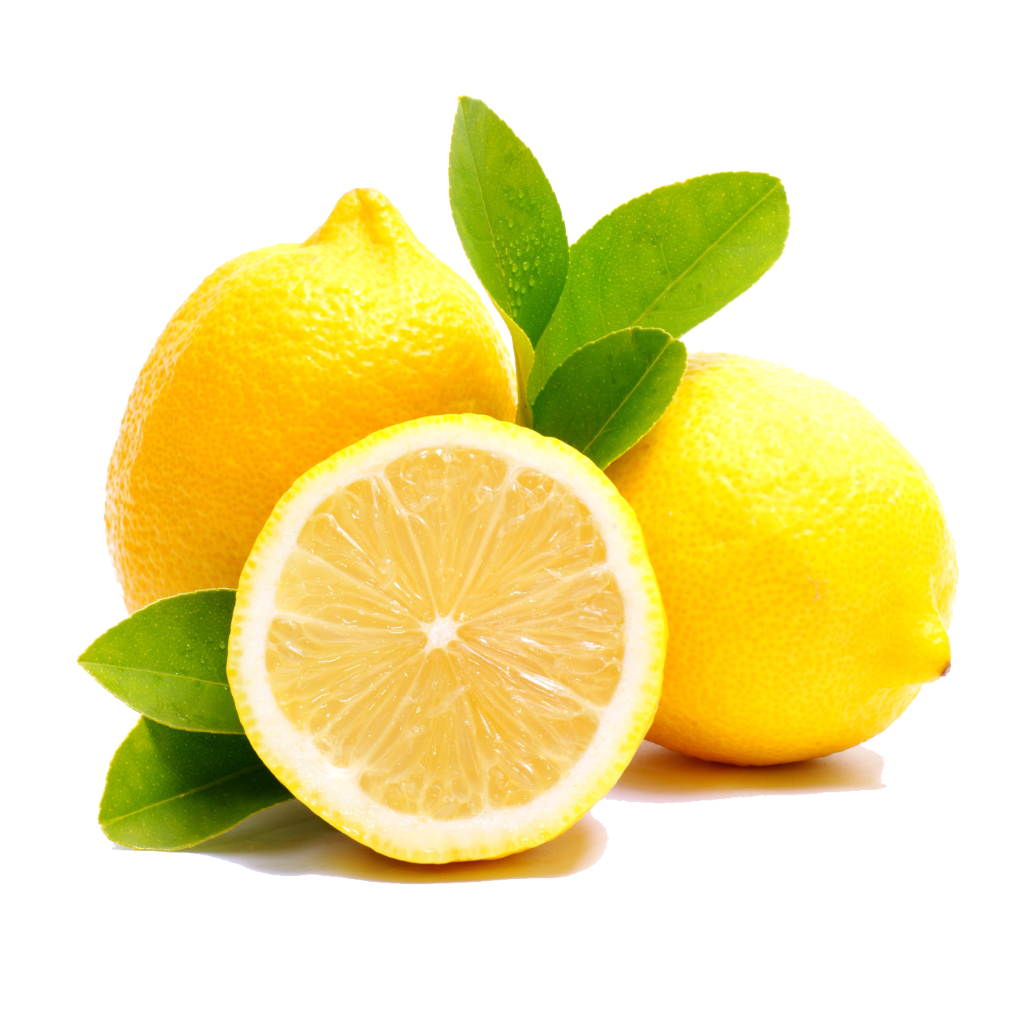
7. Elephants light. They heavy animals.

8. Lemons sweet. They sour.

9. Children young. They old.

10. Parties usually noisy. They usually quiet.

11. A library usually noisy. It usually quiet.

12. The US a country. It a city.

13. The sun cold. It hot.

14. A carrot orange. It blue.

15. Five-star hotels cheap. They expensive.

Short Answers
Write a short answer for each Yes/No question using the Be verb.
Ex. Are you a doctor? (no)
No, I’m not.
Ex. Are you a nurse? (yes)
Yes, I am.

1. Are you sick? (no)

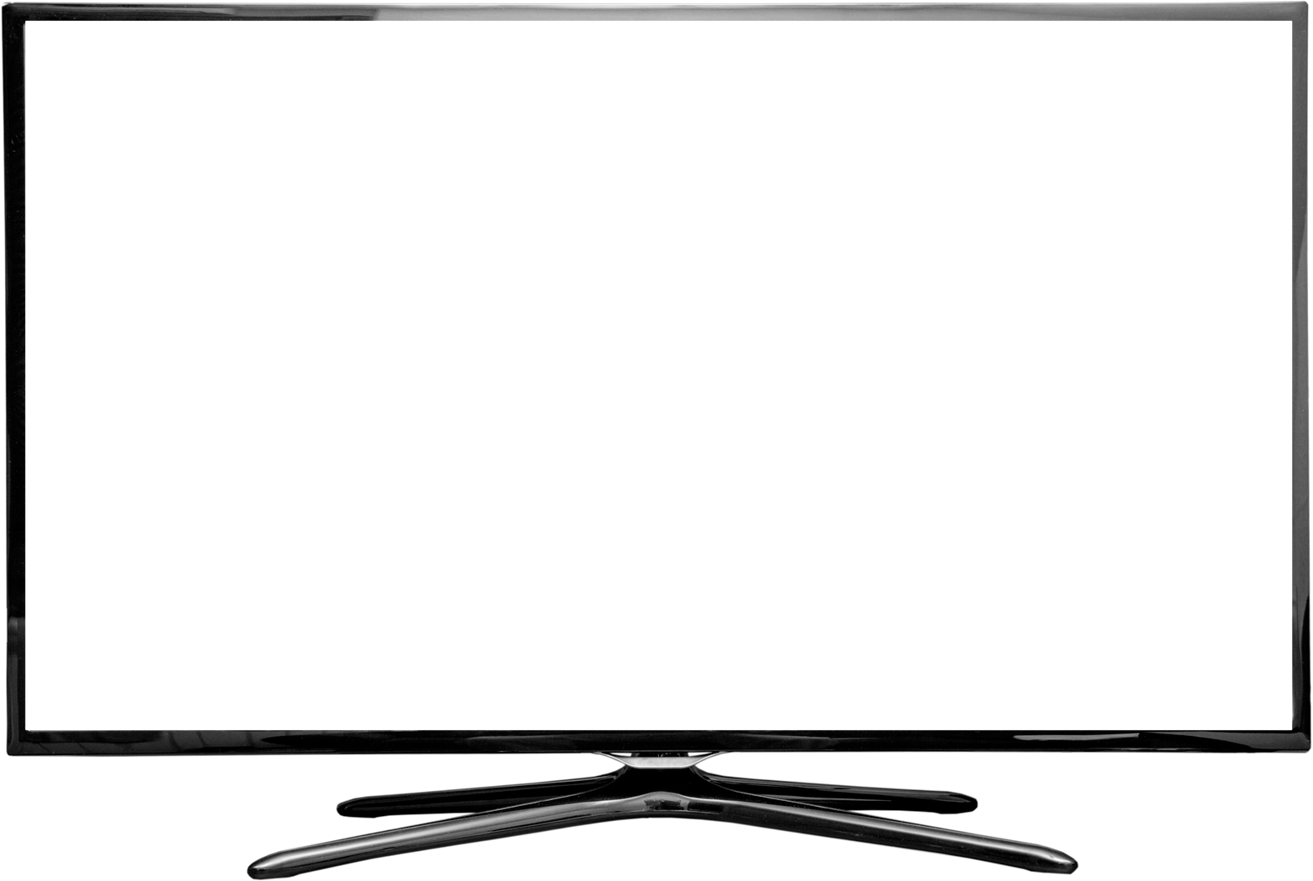
2. Are they married? (yes)

3. Is that TV expensive? (yes)

4. Is that exercise difficult? (no)

5. Are you tired? (no)

6. Is she a basketball player? (yes)

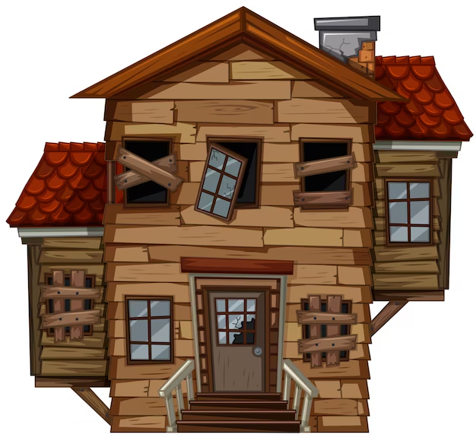
7. Are your neighbors rich? (no)

8. Is your teacher nice? (yes)

9. Is he from Spain? (no)

10. Are you happy? (yes)

Wh- Questions
Write a question using the Be verb and who, what, where, when, or why.
Ex. Where is the teacher?
The teacher is in the classroom.

1.
Tokyo is in Japan.

2.
Mr. Anderson is my teacher.

3.
It is 3:00.

4.
The doctor’s office is near the hospital.

5.
The children are in bed because they are sick.

6.
It is cold in January.

7.
Maria is John’s girlfriend.

8.
The meeting is next Monday.

9.
I am tired because I stayed up late.

10.
That beautiful woman is my mother.

Sentence Stems
Ask your partner a “Wh-“ question based on a sentence stem below, so they can answer.

Ex. The way I describe myself is…
Person 1: How would you describe yourself?
Person 2: I would describe myself as artistic, detailed, and kind.

- Before I came to Vermont, my main interests were...
- The way I would describe my family is...
- My fondest memories of another person are...
- My most unusual friend is...
- The things I value most are...
- My favorite pastimes are...
- Some of the things that make me happy are…
- Where I hope I will be five years from now...
- Some things I will do this year are...
- The thing that worries me most about English is...

Self Introduction Speaking
Read the dialogue with your partner. Then switch roles and read it again.

Juan: Hi, I’m Juan.

Marie: It’s nice to meet you, Juan. I’m Marie.

Juan: Hi, Marie. Where are you from?

Marie: I’m from France. How about you?

Juan: I’m from Mexico.

Marie: What do you do in Mexico?

Juan: I’m a photographer. What do you do, Marie?

Marie: I’m a realtor. I sell houses.

Juan: Well, it was nice to meet you, Marie.

Marie: You too, Juan. See you later.
Work with a partner and fill in the dialogue with your own information. Then read it out loud.

A: Hi, I’m .

B: It’s nice to meet you, . I’m .

A: Hi, . Where you from?

B: from . How about you?

A: from .

B: What do you do in ?

A: a . What do you do, ?

B: a .

A: Well, it was nice to meet you, .

B: You too, . See you later.

Self Introduction Fill in the Blank

Hello, my name is __________. I am ____ years old and I work at ________. My hometown is ______________ and I really ________ it there because ______________. I always dreamed that someday I would ________________, and that dream has ______ true. I feel __________ about it now! Some things I like to do include ______________. There are many things I am good at and one of them is ______________. I did a really interesting thing once and that was ____________. My family consists of ______________. If I could change one thing about myself it would be _____________. Still, I am really glad to be here right now because ______________. I would really like to get together with anyone who be interested in _________________. The one thing I want to be remembered for is _______________. As far as future plans are concerned, I hope to be ________________ someday.

Multiple Choice Quiz
Circle and write the correct answer.

1. I hungry.
a) is
b) am
c) are

2. Onions and beans vegetables.
a) are
b) am
c) is

3. You a student.
a) are
b) isn’t
c) am

4. It cloudy today.
a) are
b) is
c) am

5. Brazil in Europe.
a) isn’t
b) not be
c) am not

6. late?
a) I am
b) Do I
c) Am I

7. Why tired?
a) is you
b) are you
c) you be

8. A mouse under the table.
a) is
b) am
c) are

9. Cows farm animals.
a) is
b) are
c) to be

10. What your name?
a) be
b) are
c) is

Answers

Opening Discussion
- How are you?
- What did you do today?
- Will you do anything fun this weekend?.

Positive Sentences
1.I am
2. we are
3. he is
4.hey are
5. you are

Fill in the Blank
1. is
2. is
3. is
4. are
5. is
6. is
7. is
8. is
9. are
10. is
11. are
12. are
13. are
14. is
15. is
16. is
17. am
18. are
19. are
20. are

Complete the Sentence
1. is an animal
2. are flowers
3. is a car
4. are cities
5. is a country
6. is a book
7. are seasons
8. is a person
9. is a toy
10. are insects
11. is a bird
12. are clothes
13. is a movie
14. are instruments
15. are vegetables

Positive and Negative Sentences
1. is, isn’t
2. isn’t, is
3. are, aren’t
4. is, isn’t
5. are, aren’t
6. is, isn’t
7. aren’t, are
8. aren’t, are
9. are, aren’t
10. are, aren’t
11. isn’t, is
12. is, isn’t
13. isn’t, is
14. is, isn’t
15. aren’t, are

Short Answers

1.No, I’m not.
2. Yes, they are.
3. Yes, it is.
4. No, it isn’t.
5. No, I’m not
6. Yes, she is.
7. No, they aren’t.
8. Yes, he/she is.
9. No, he isn’t.
10. Yes, I am

Wh- Questions
1. Where is Tokyo?
2. Who is your teacher?
3. What time is it?
4. Where is the doctor’s office?
5. Why are the children in bed?
6. When is it cold?
7. Who is Maria?
8. When is the meeting?
9. Why are you tired?
10. Who is that beautiful woman?

**
"To be, or not to be" is a speech given by Prince Hamlet in the so-called "nunnery scene" of William Shakespeare's play Hamlet.
https://www.poetryfoundation.org/poems/56965/speech-to-be-or-not-to-be-that-is-the-question

To Be PAST Practice
https://www.grammarbank.com/to-be-past-tense.html
https://www.grammarbank.com/simple-past-verb-tense.html
https://www.grammarbank.com/was-or-were-exercise.html

Present and Past Practice
https://www.grammarbank.com/was-were-am-is-are.html
https://www.grammarbank.com/was-were-am-is-are-exercise.html

More Practice Online
https://www.grammarbank.com/verb-to-be.html
https://www.grammarbank.com/to-be-verbs-tenses.html
https://www.grammarbank.com/verb-to-be-exercise.html
https://www.grammarbank.com/am-is-are-exercise-3.html
https://www.grammarbank.com/am-is-are-exercise-4.html
https://www.grammarbank.com/am-is-are-exercise-dd1.html
https://www.grammarbank.com/am-is-are-exercise-dd2.html

https://www.youtube.com/watch?v=MPZtof4g1uQ&t=2s
https://www.youtube.com/watch?v=aEqfqMlGuqI

Credits
https://app.ellii.com/lesson/1591-simple-present-be

