Lesson by Julie 5.01.23
Green Up Day
May 4 @ 8:00 am - 1:00 pm
(First Saturday in May)
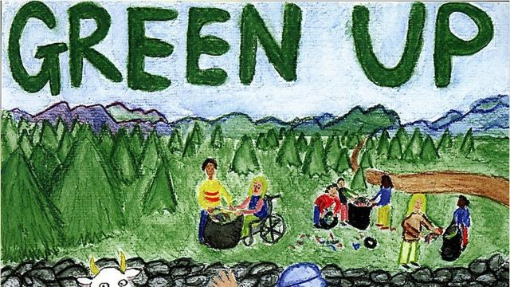
What is green?

What do you think Vermonters do on Green Up Day?

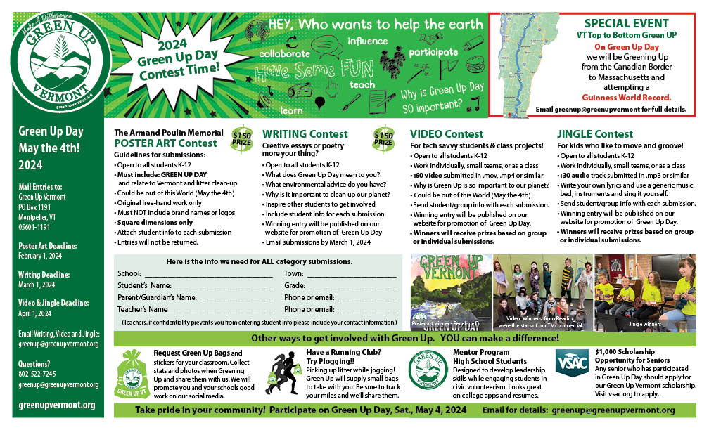Green Up Day Poster Art Contest
https://greenupvermont.org/wp-content/uploads/2023/10/2024-Contest-info.pdf
Look at the posters and answer these questions:
- What do you see in these posters?
- Who made these posters?
- Why do you think these posters were made?

The Armand Poulin Memorial Green Up Day
Poster Art Winners are…

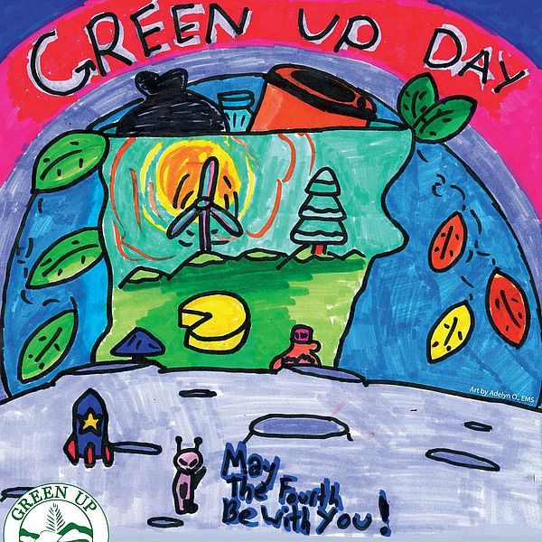

2024 winner is Adelyn O. Grade 7, Essex Middle School
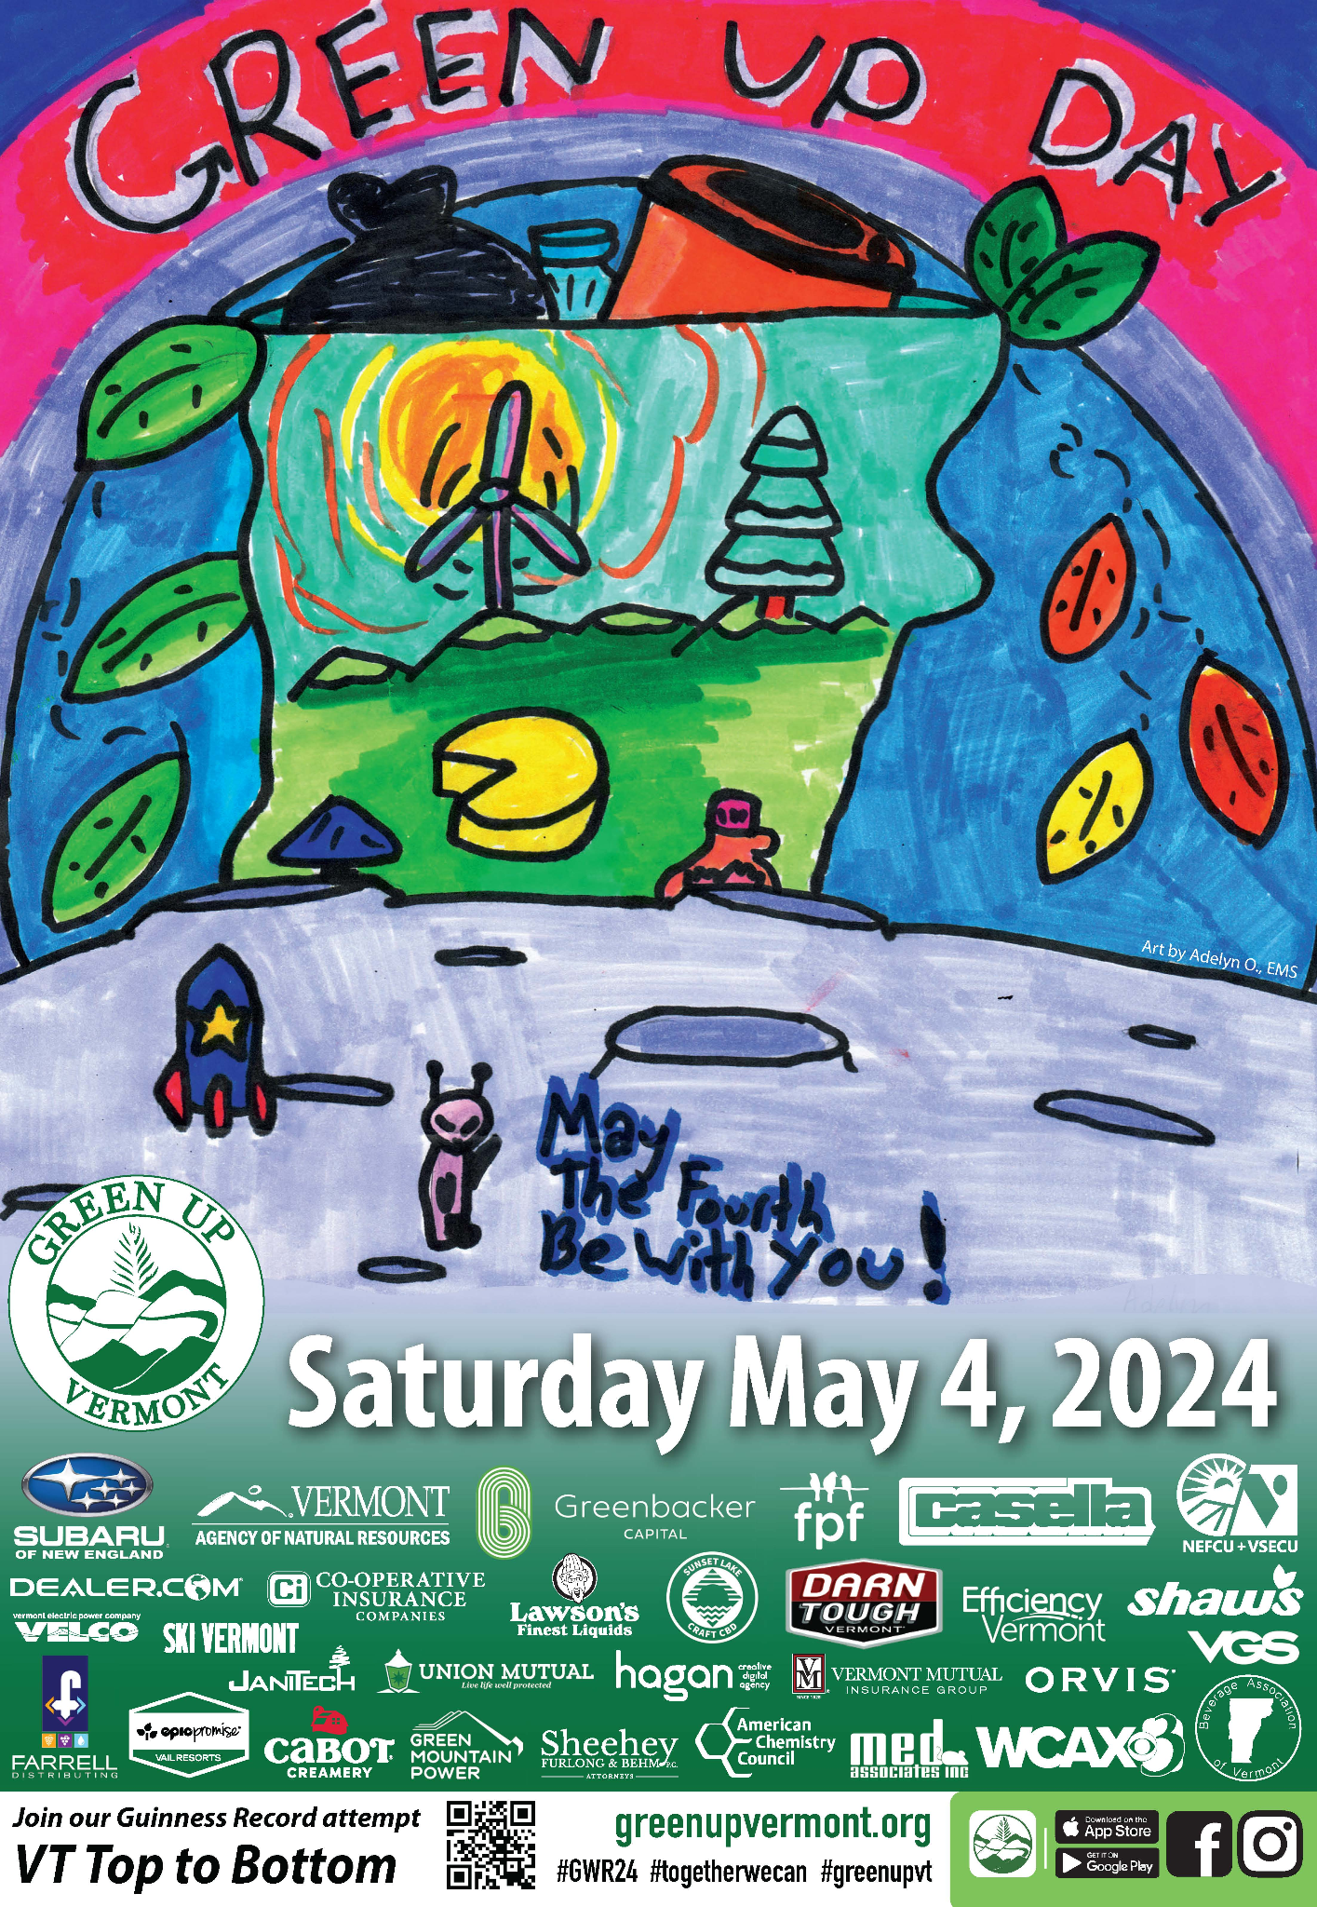

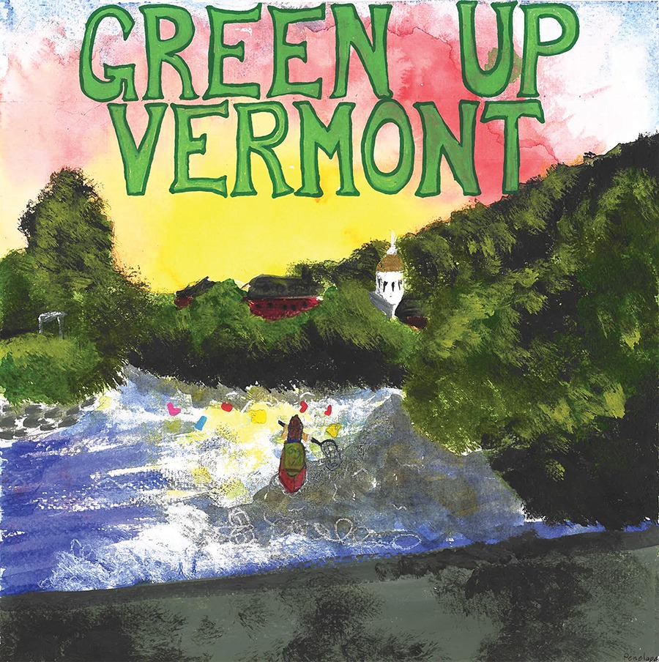

Last year’s winner is Penelope D. Grade 5, Ludlow
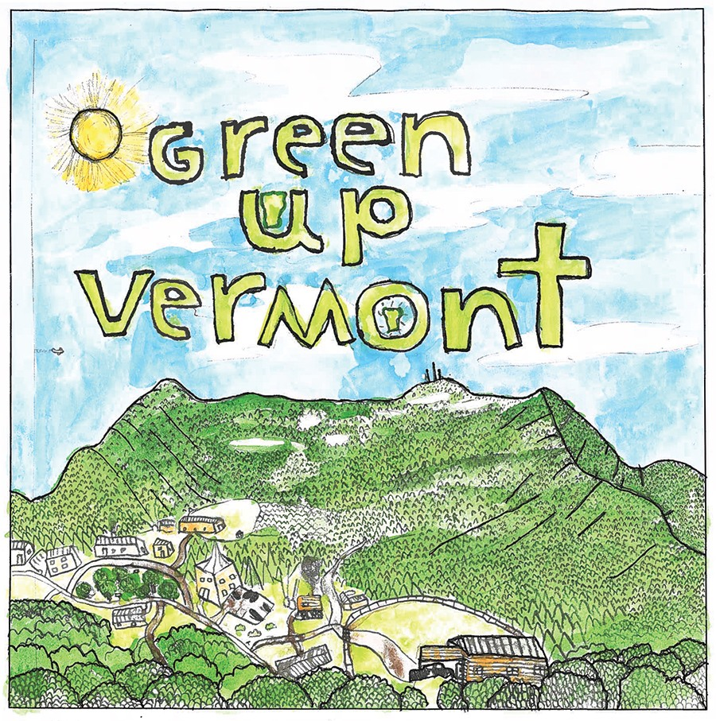

K-4 category winner is Gabriel S. Grade 4, Underhill

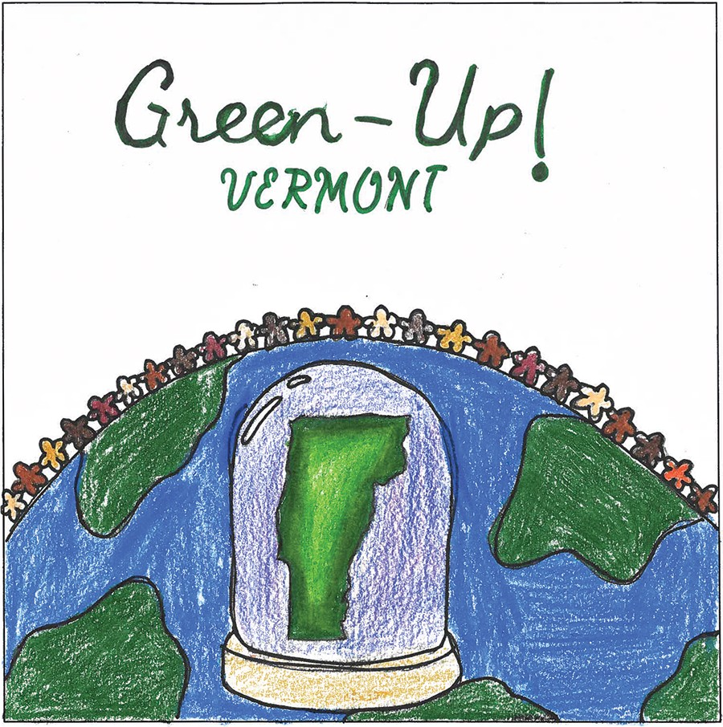

Audrey L. Grade 8, Shelburne

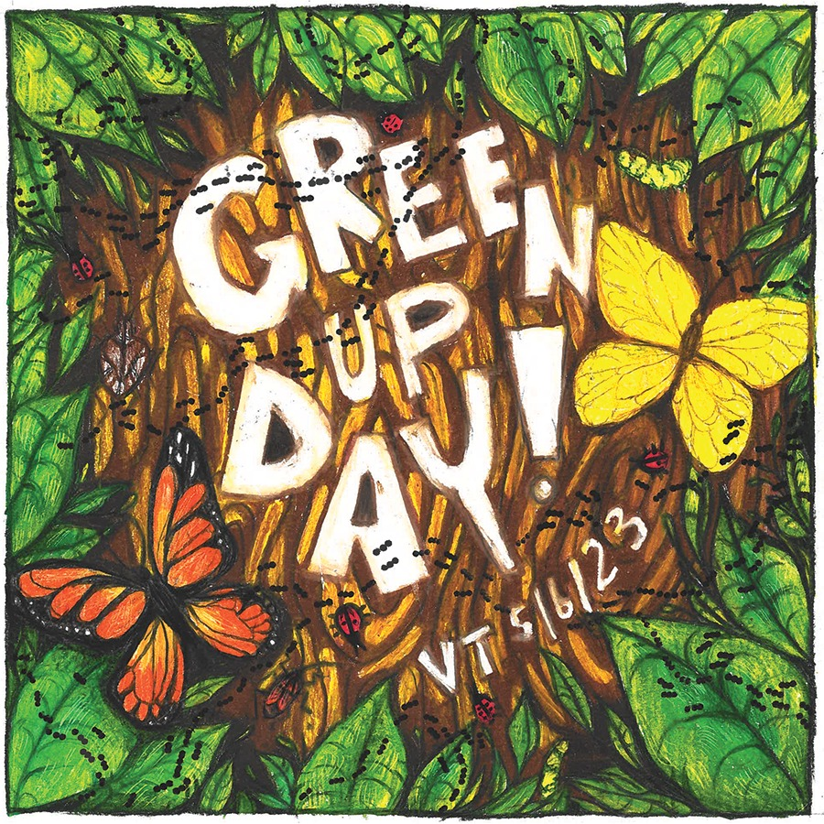
Amelie M. Grade 10, Dorest

Green Up Day Video
https://www.youtube.com/watch?v=ZcmA-2DmToo&ab_channel=OkemoValleyTV

- What time of year is it?

- Who do you see in the video?

- What are they wearing?

- What do the people in the video do on Green Up Day?

- Why are they doing this?

- What color are their bags?

Vocabulary What do you see? Guess the word.
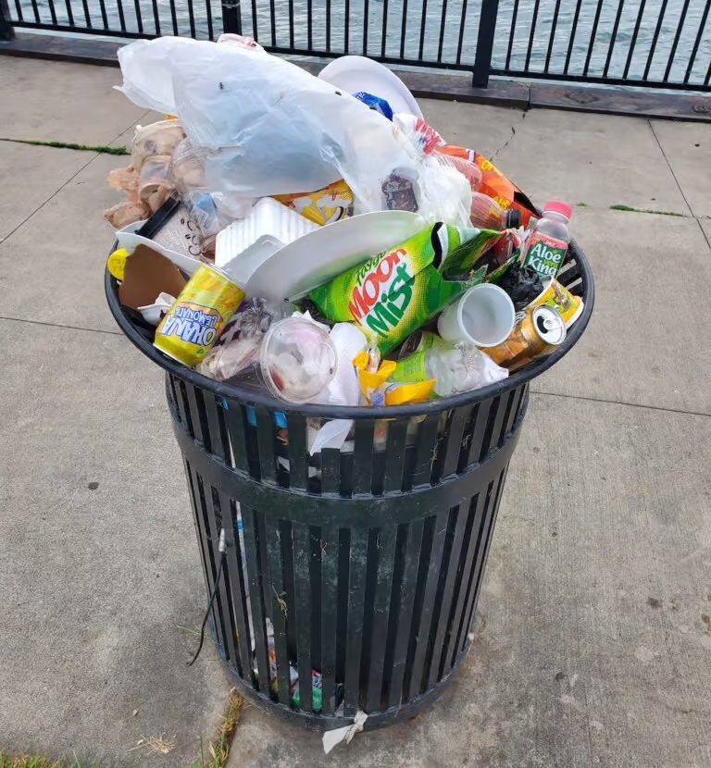  Trash | 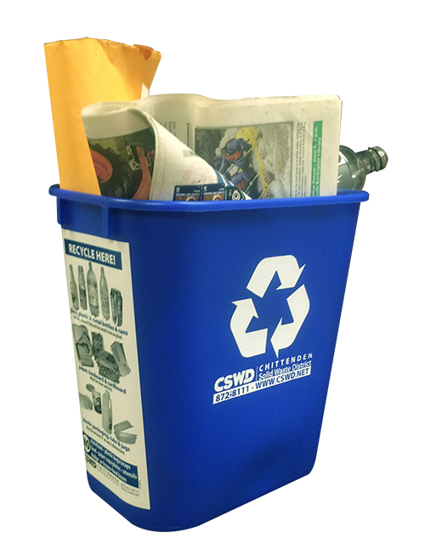  Recycling | 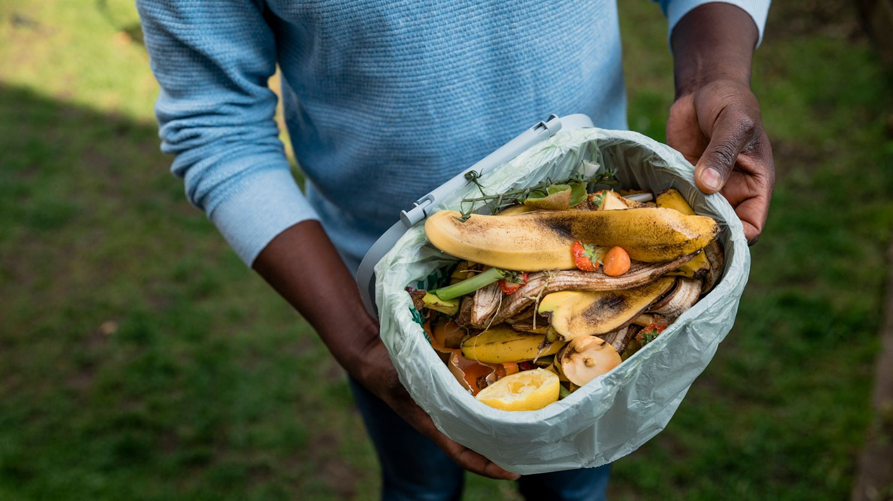  Compost
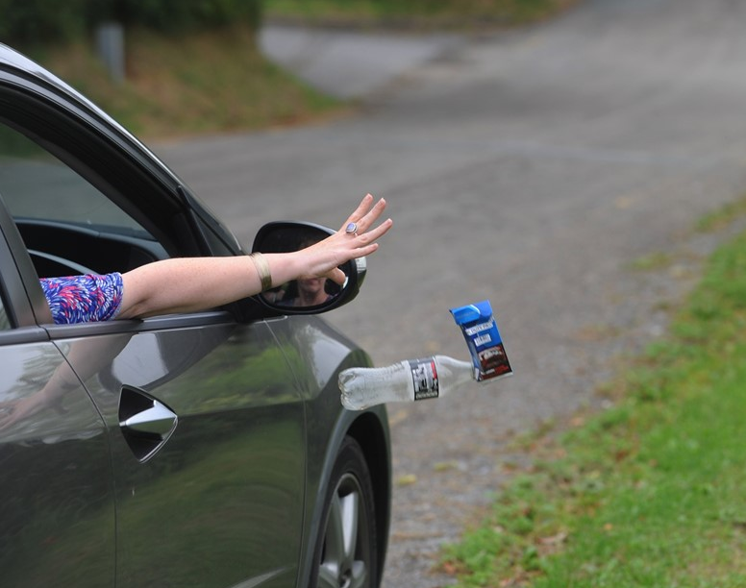  Litter | 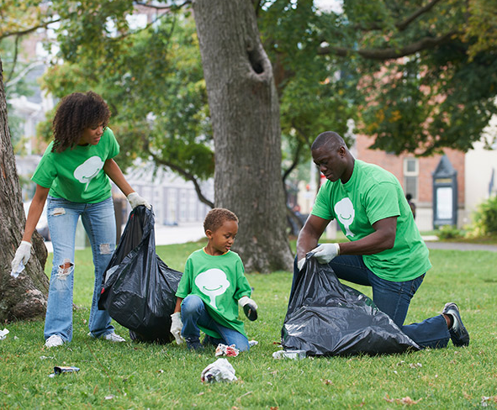  Clean-up | Green
Earth | Nature | 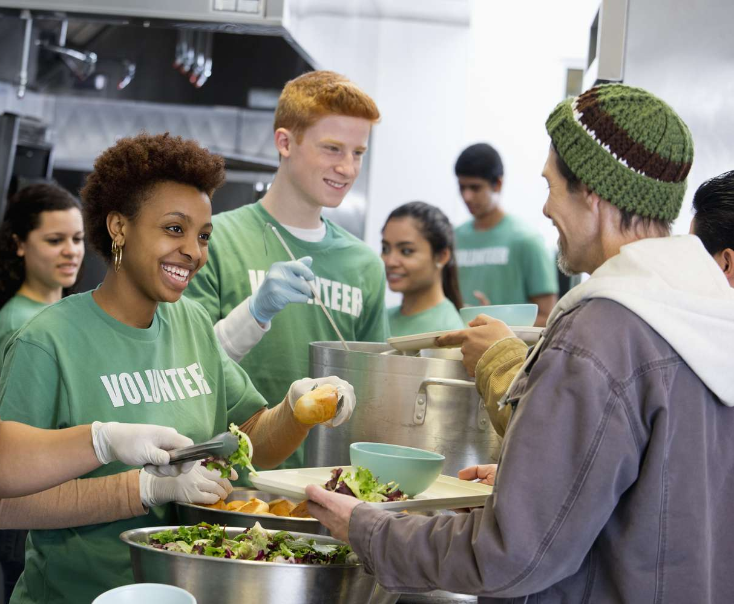  Volunteer
Eco-friendly / “Green” | Environment | Vocabulary Flashcards  https://quizlet.com/799385204/flashcards?funnelUUID=45f38bd4-defa-4d09-89e0-746619510eb2

Multiple Choice
1. What do we call things we don't want or use anymore and throw away?
A) Recycling
B) Compost
C) Trash

2. What do we call the world around us, including the air, water, and animals?
A) Nature
B) Recycling
C) Compost

3. Turning food scraps and yard waste into healthy nutrient-rich soil is called…
A) Recycling
B) Compost
C) Green

4. What do we call materials that can be used again instead of throwing them away?
A) Green
B) Recycling
C) Litter

5. What do we call items that are thrown on the ground instead of being put in a trash can?
A) Compost
B) Litter
C) Clean-up

6. What do we call the act of picking up trash to make an area look better?
A) Recycling
B) Clean-up
C) Nature

7. What do we call the planet we live on?
A) Earth
B) Eco-friendly
C) Volunteer

8. What do we call products or actions that are kind to the environment?
A) Eco-friendly
B) Recycling
C) Litter

9. What do we call a person who works to help others without getting paid?
A) Eco-friendly
B) Clean-up
C) Volunteer

10. What is both a color, and what we call items that are good for the environment and don't harm it?
A) Green
B) Recycling
C) Litter

11. What do we call the day we volunteer to pick up trash, recycling, and compost to keep our environment clean and healthy?
A) Earth Day
B) Green Up Day
C) Clean Up Day

Fill in the Blank
- __________ is all of the things around us, like air, water, plants, and animals.

- We can help keep our __________ clean by putting our waste in the trash can.

- When we separate items like plastic, glass, and paper from our trash and they are made into new things, it's called __________.

- __________ is when people pick up trash to help keep the environment clean.

- __________ is anything that has been thrown away that is no longer needed or wanted.

- __________ is the natural world around us, like trees, flowers, and animals.

- __________ materials are things that are good for the environment and don't cause harm to plants, animals, or people. Also, the color of spring!

- A __________ is someone who chooses to help others by doing work without getting paid.

- __________ is a process where natural waste, like food scraps and leaves, is broken down into nutrient-rich soil.

- Using energy like wind or solar power, instead of burning gas, is one way to be more __________.

- __________ is trash that is left in places where it shouldn't be, like on the side of the road or in a park.

The Importance of Greening Up Our State
Poem by Juliette B. Grade 8, Worcester

I didn’t really think about the environment until it actually impacted me.
I was driving to the city with my dad when I noticed the amount of trash on the side of the road.
The city smelt, the ground was dirty, and it was because no one was taking care of the environment.
In Vermont, there’s very few instances where I feel that way.
There’s no smell besides the fresh air smell.
The ground isn’t littered with trash, it’s littered with plants.
If we don’t take care of our environment, our children will have to do it.
By then, it’ll be way worse.
Global warming, littering, and pollution are serious problems.
Even just picking up your trash and sorting it into recycling is helping.
It’s the little actions that matter, they’re small, but mighty.
As my mom used to say, “If everyone chips in, it’ll make the work easier and faster.”
Our global issues might not go away overnight, but if we start now, it’ll go away faster.
Poem Reflection Questions

- What made Juliette think about the environment?

- What did Juliette notice while driving to the city with her dad?

- How did the city smell and look to Juliette?

- How does Juliette compare Vermont to the city?

- Why is it important to take care of the environment?

- What are some of the serious problems happening to the environment?

- Why do little actions matter?

- What did Juliette's mom say about “chipping in”?

2024 Green Up Day
Green Up Day is a much-loved, spring clean-up tradition in Vermont. It is a special day when people come together to help clean up our communities. This year is the 53rd annual Green Up Day. Vermonters will hit streets, parks, and sidewalks to pick up trash. Volunteers will gather May 4th to grab their green trash bags and gloves and clean up Vermont one piece of litter at a time.
It's important to clean up our litter because it helps us to be healthy and makes our cities and towns look good. Over 400 tons of trash were collected in 2023, winning Vermont the title of "Cleanest State”.

- When is Green Up Day 2023 going to be held?

- What do people do on Green Up Day?

- Why is Green Up Day important?

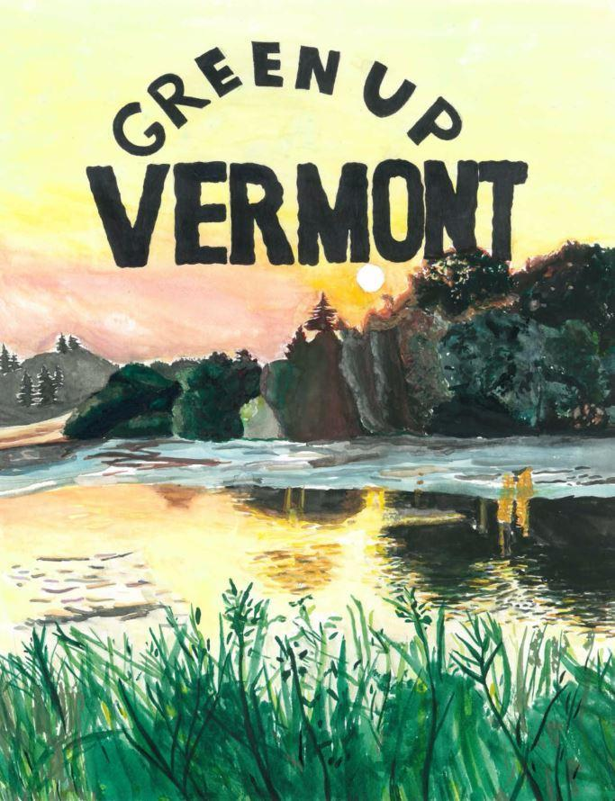
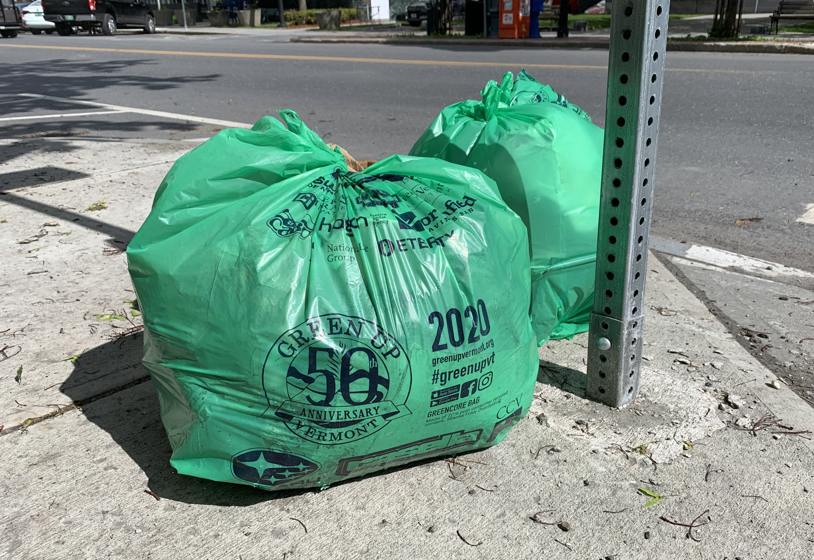
Starting at 8 a.m., volunteers can pick up their official green bags, go for a walk, and pick up any trash they see. We know it isn’t your litter but Vermont needs our help to be beautiful! You can help by picking up litter with free green bags provided by your town. It makes a huge difference and it feels great to give back to your community.
Only official Green Up Day bags can be used on Green Up Day. Household trash, bulk items, or clean recyclables will not be collected. Full bags can be left on major roadsides for pick up by City trucks, or in the parks near a trash can for Parks staff to pick up.
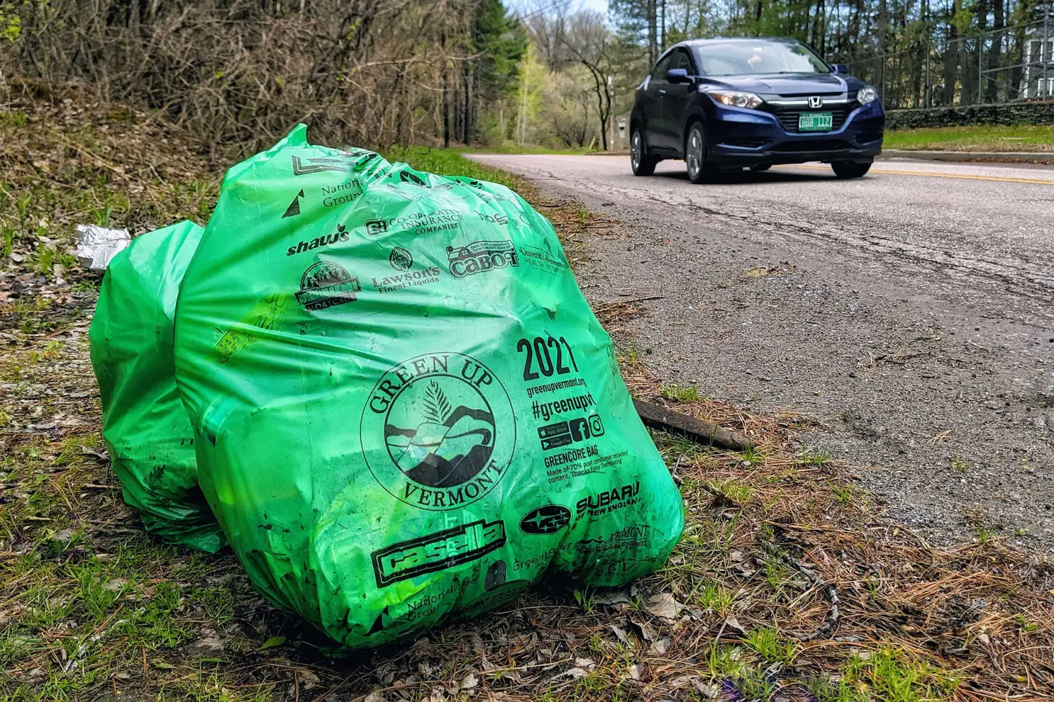
In Burlington, Green Up Day Bags will be available starting April 30 at the following locations:
- Miller Recreation Center (open weekends, will have bags on May 4)
- 645 Pine Street (closed weekends)
- City Hall CEDO Office, 3rd floor (closed weekends)
- Burlington Subaru

- How can you help Vermont stay beautiful?

- Can you use any bag to pick up litter on Green Up Day?

- Where can you get Green Up Day bags in Burlington?

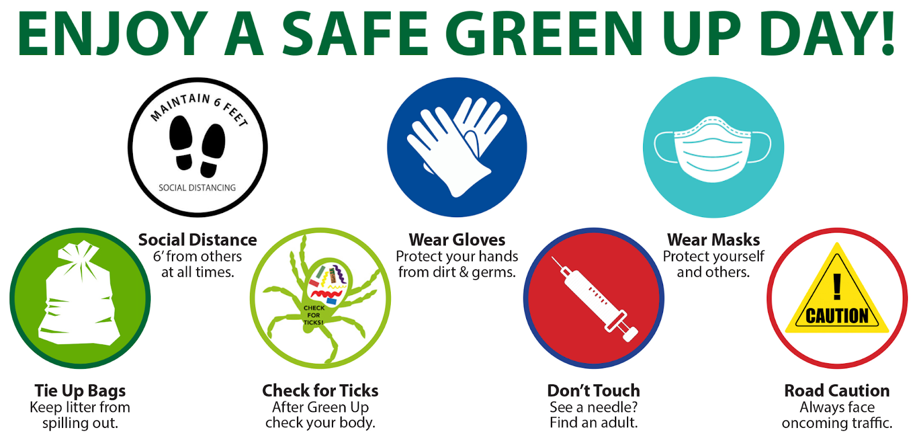
Be safe on Green Up Day!
• WEAR GLOVES.
• Wear long pants, boots, and be prepared for the weather.
• Check your body for ticks when you get home.
• Tie your trash bag closed when full – keep your good work in the bag!
• If you see a needle or sharp material – do not put it in your bag with the other trash!
Put it in a thick plastic container, clearly write “DO NOT RECYCLE” on the container with a marker, and duct tape the lid on. Then you can put it into the regular trash.
• Road Safety: Always walk facing oncoming traffic when you walk on the side of the road. Wear bright-colored clothes.

- What should you wear to stay safe on Green Up Day?

- What should you do if you find a needle or sharp material while picking up litter?

- How should you walk on the side of the road to stay safe on Green Up Day?

GUINNESS BOOK OF WORLD RECORD ATTEMPT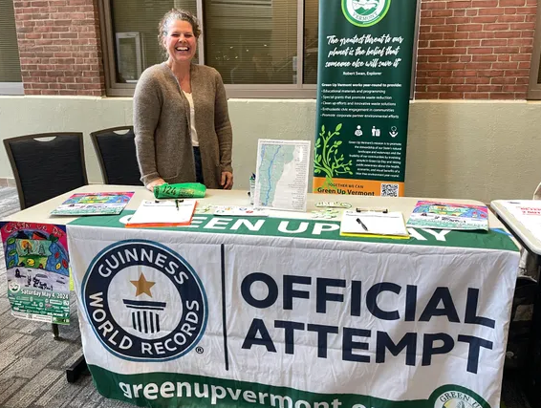
This year, Vermont’s Green Up Day coordinators are working to set a world record for The Most Pledges Received to Clean in 24 Hours.
We need to sign up 5,000 Vermonters to set the record VT Top to Bottom Green Up – From Canada to Massachusetts – Green Up Vermont is organizing the longest litter pick up team ever.

• 223 miles from North Troy to Stamford – 446 if we go North & South
• Volunteers start at every mile mark
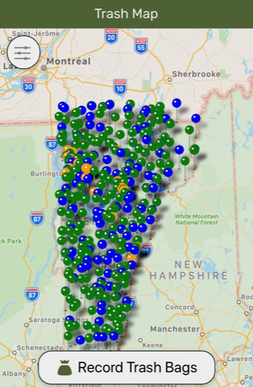
• Route complete in about one hour
To sign the pledge, people can visit the website or download their app, Green Up Vermont. There will also be events leading up to and on Green Up Day that will have the sign-up sheets. Together we build pride in our cities and towns and teach our youth about our environment.

The History of Green Up Vermont
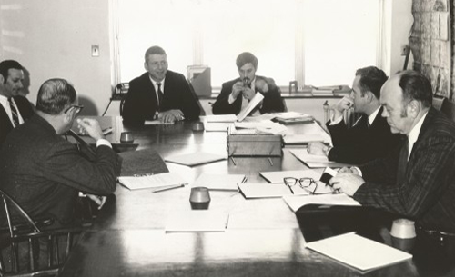
1969
FROM IDEA…

Robert Babcock (right of center), a Burlington Free Press reporter, talks to Governor Deane Davis about the idea of cleaning up Vermont’s roadsides. Governor Davis decides they need a year to plan the event and appoints Robert Babcock and Ted Riehle (left of center) from his senior staff to make it happen.

- Who is the person on the right side of the picture talking to Governor Deane Davis?

- Who did Governor Davis choose to plan the event of cleaning up Vermont's roadsides?

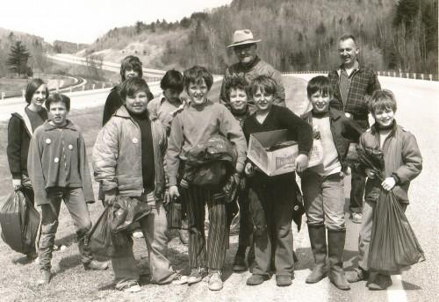
1970
…TO REALITY

In 1970, the Governor of Vermont, Deane Davis, started the first Green Up Day. The Interstate Highways closed 9am–12pm for litter pick up by volunteers. Lots of kids from schools all over Vermont helped out too. The Governor even flew in a helicopter and landed on the highway to say thank you to the volunteers.

- Who started the first Green Up Day in Vermont?

- How did the Governor of Vermont show his appreciation for the volunteers?

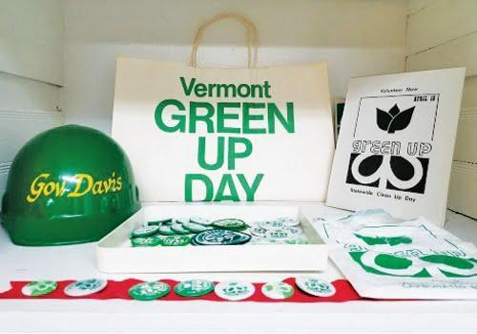

After the first Green Up Day, newspapers reported that it was a big success. 70,000 people helped clean up almost 100% of the roads.

They found out that 90% of the litter they picked up were beer bottles, so the government made a new law called the "Bottle Bill." This helped save money on cleaning up the roads, which is good for everyone. It saved taxpayers $200,000.

- What did the government do after finding out that 90% of the litter picked up were beer bottles?

- How much money did the taxpayers save from Green Up Day?

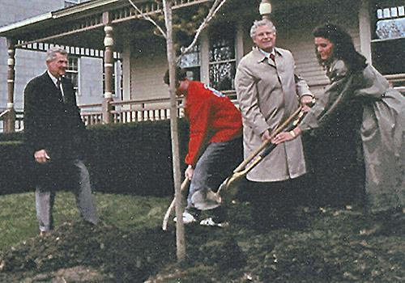
1979
A PRIVATE NONPROFIT

After almost 12 years directed by the Governor’s office, a group of Vermonters who cared about keeping Vermont clean decided to work together to make sure Green Up Day kept going.

They made a group called Vermont Green Up Inc. and took charge of organizing Green Up Day. One Vermonter named Merrill Durdan started Green Up Vermont by making it a legal organization in a town called Shoreham.
- Who started the organization called Vermont Green Up Inc.?

- Where did Merrill Durdan make Green Up Vermont a legal organization?

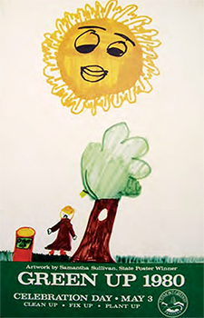
1980
THE POSTER ART CONTEST

Every year, kids in Vermont can enter the Green Up Poster Art Contest by drawing their best artwork. The winning picture is chosen by judges and the winner gets a prize and a chance to meet the governor at the statehouse. The winning artwork is then used on the Green Up Day poster and other promotions.

- What can kids do in Vermont every year to show their love for the environment?

- What happens if someone wins the Green Up Poster Art Contest in Vermont?

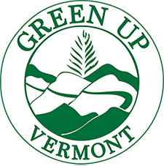
1995
STRUCTURE & STABILITY

In the 1990s, things were tough for the Vermont Green Up group. The boss, Sheldon Prentice, got a loan to help. Then, they hired Melinda Vieux to be the leader. Melinda wanted to make the name of the group sound more active, so she changed it from Vermont Green Up to Green Up Vermont.

- Who helped the Vermont Green Up group when things were tough in the 1990s?

- Who was hired to lead the Vermont Green Up group?

- What did Melinda Vieux change the name of the group to and why?

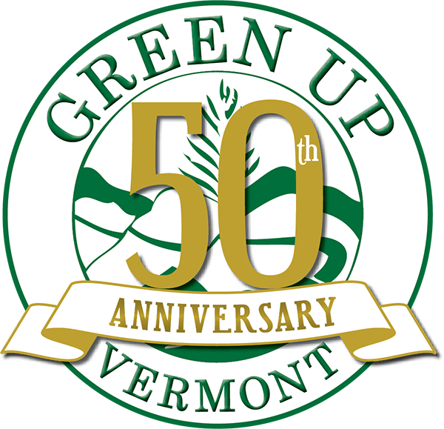
2020
WE CELEBRATED 50 YEARS!

In 2020, Green Up Vermont had its 50 year anniversary. They have been cleaning up the environment in Vermont for 50 years. If we count how much trash they have collected and how many tires they've found, it adds up to over 24 million pounds of litter and 450,000 tires!

- What was the occasion that Green Up Vermont celebrated in 2020?

- How much trash has Green Up Vermont collected and how many tires have they found over the years?

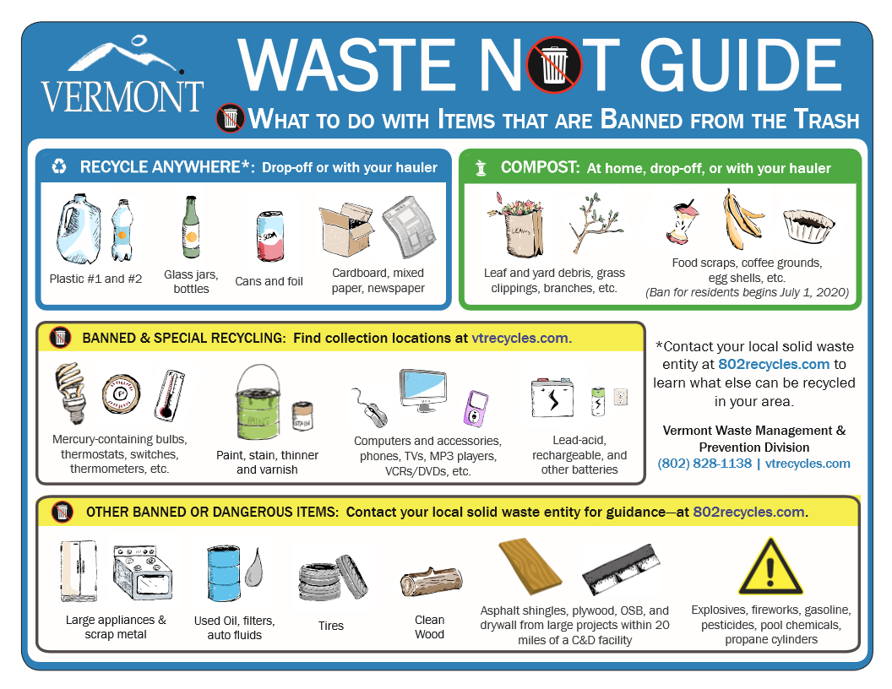
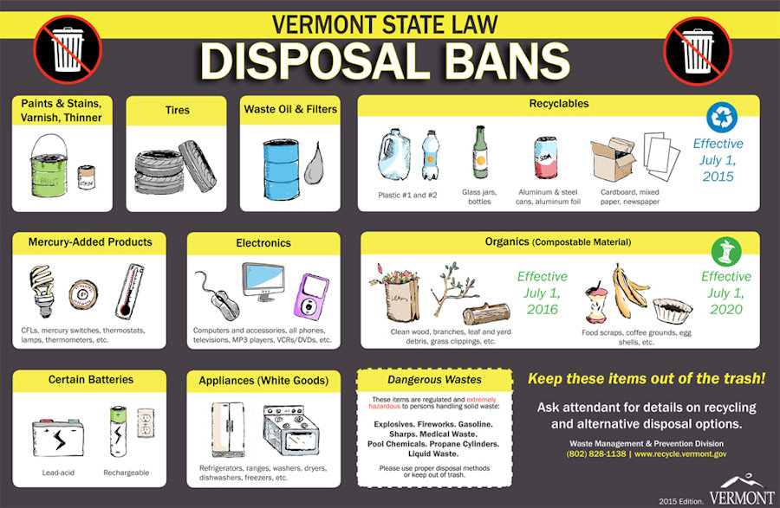
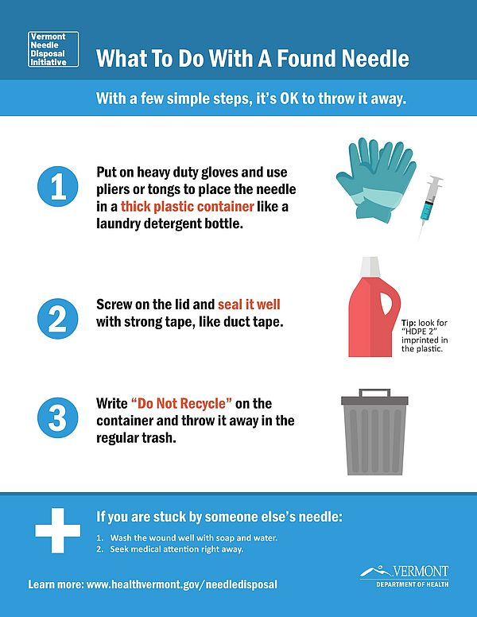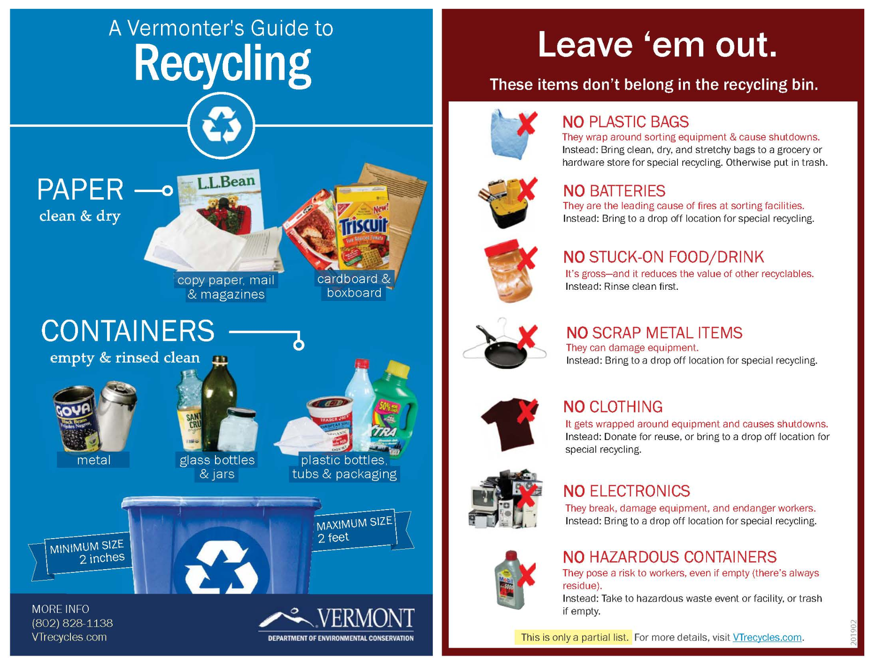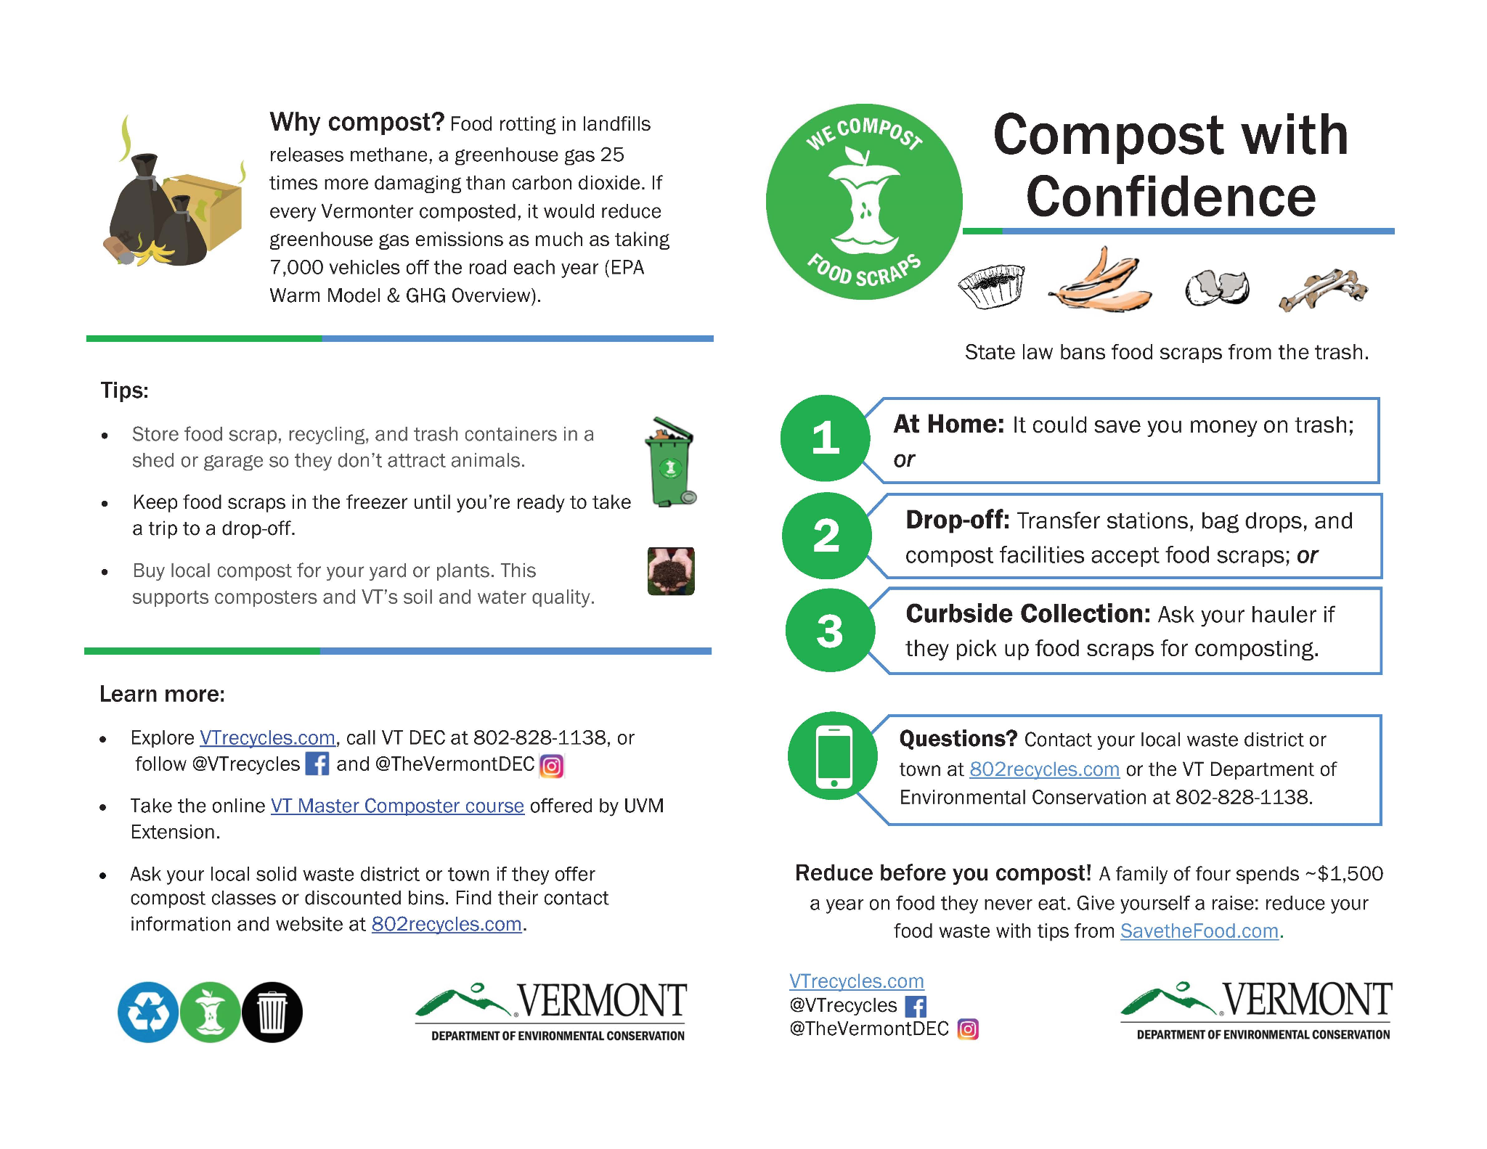
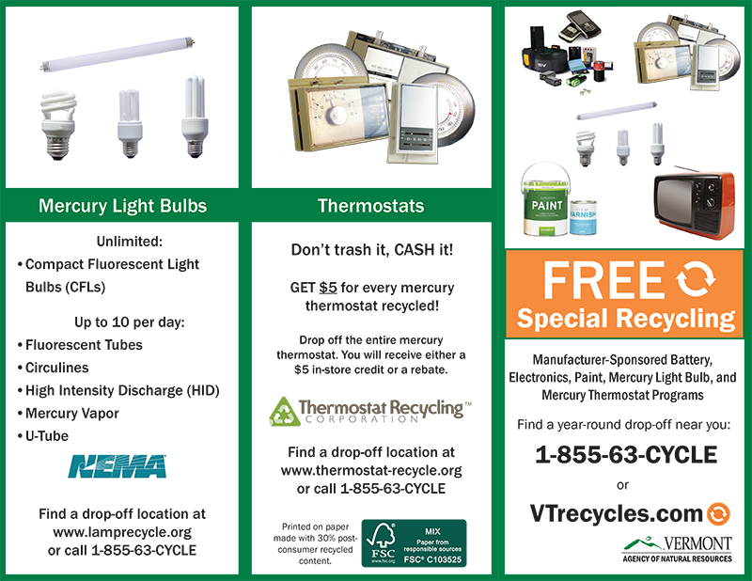

Glossary
Trash - Stuff that people throw away because they don't need it anymore.

Recycling - Changing old things into new things instead of throwing them away.

Eco-friendly - Things that are made or done in a way that helps the Earth stay healthy.

Earth - The big planet we live on with everything on it, like plants, animals, and people.

Clean-up - Picking up trash or garbage from an area to make it clean and nice.

Nature - All the living things (plants and animals) and things that aren't man-made, like rocks, rivers and the weather.

Green - A color that we see a lot in nature, like grass and leaves on trees.
Litter - Trash or garbage that people throw on the ground instead of putting it in the trash can.

Compost - Old food and plants that are mixed together and used to help plants grow.

Environment - Everything around us, like the air we breathe, the water we drink, and the land we walk on.

Volunteer - A person who chooses to do something helpful without being paid. They do it because they want to help and make a good change in their community.

Answers
What is This?
From left to right: Trash, Recycling, Compost, Litter, Clean-up, Green, Earth, Nature, Volunteer, Eco-friendly, Environment

Multiple Choice Answers
- C) Trash
- A) Nature
- B) Compost
- B) Recycling
- B) Litter
- B) Clean-up
- A) Earth
- A) Eco-friendly
- C) Volunteer
- A) Green
- B) Clean-up

Fill in the Blank Answers
- Environment
- Earth
- Recycling
- Clean-up
- Trash
- Nature
- Eco-friendly
- Volunteer
- Compost
- Green
- Green Up Day

Green Up Day Video Answers
- It is Spring
- People of all ages
- Gloves, masks, long sleeves, green for fun, long pants, orange vests
- They are cleaning up together.
- They are cleaning up together because there is too much litter.
- Green

Green Up Day 2023 Answers
- Saturday, May 4, 2024
- Pick up litter on the sides of the roads, in parks, and other public areas.
- It helps us stay healthy and makes our cities and towns look nicer.
- By picking up litter.
- No, you can only use official Green Up Day bags.
- You can get them at local businesses and parks.
- You should wear long pants, boots, and gloves to stay safe.
- Before you put it in the trash, put it in a thick plastic container, clearly write “DO NOT RECYCLE” on the container with a marker, and duct tape the lid on.
- You should walk facing traffic.

The History of Green Up Vermont Answers
- Robert Babcock, a reporter.
- Robert Babcock and Ted Riehle.
- The Governor of Vermont, Deane Davis.
- The Governor flew in a helicopter and landed on the highway to say thank you to the volunteers.
- The government made a new law called the "Bottle Bill."
- Taxpayers saved $200,000 from Green Up Day.
- A group of Vermonters who cared about keeping Vermont clean started the organization called Vermont Green Up Inc.
- Merrill Durdan made Green Up Vermont a legal organization in Shoreham.
- Kids in Vermont can enter the Green Up Poster Art Contest every year.
- The winner of the Green Up Poster Art Contest in Vermont gets a prize and a chance to meet the governor at the statehouse. The winning artwork is also used on the Green Up Day poster and other promotions.
- The boss, Sheldon Prentice.
- Melinda Vieux was hired to be the leader.
- Melinda wanted to make the name of the group sound more active, so she changed it from Vermont Green Up to Green Up Vermont.
- Green Up Vermont celebrated its 50 year anniversary.
- Green Up Vermont has collected over 24 million pounds of litter and found 450,000 tires over the years.
Credit:
https://greenupvermont.org/about-guv/

Useful Links:
Green Up Vermont Facebook:
https://www.facebook.com/GreenUpVermont/
Green Up Vermont Website:
https://greenupvermont.org/
Where to get and bring bags- click “Details” next to the name of your town:
https://greenupvermont.org/towndetails/
Green Up App: https://apps.apple.com/us/app/green-up-vermont/id1364770239?ls=1
https://play.google.com/store/apps/details?id=org.greenupvermont.app&pli=1
2023 Green Up Day Jingle Winners:
https://www.youtube.com/watch?v=iDY9XUSYxSI&ab_channel=greenupvt
Extra Resources:
https://greenupvermont.org/resources/

